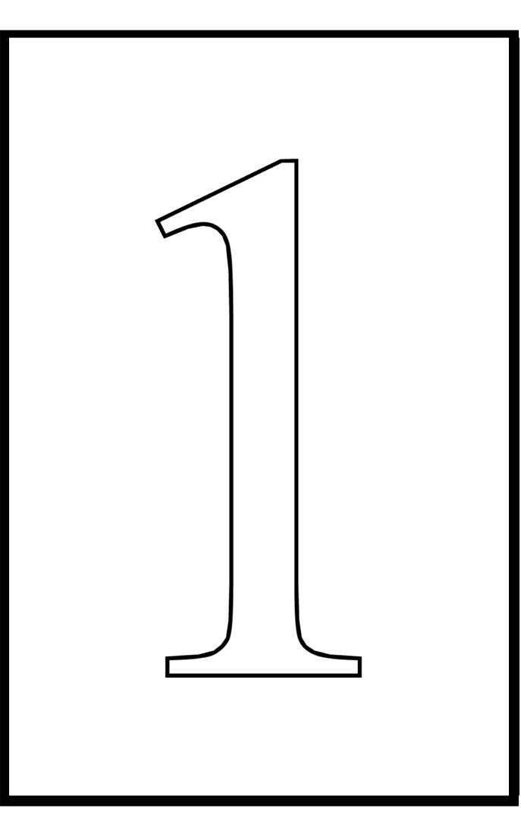
Scholarship Nomination Form
To nominate a CAWA member, please complete this form and give it to any board member. Please type or print all information. Additional or supporting information on the nominee should be attached to the nomination form.
EVENT: SWS Other (description)__________________________
Please provide the nominee’s contact information:

Nominee’s Name:

Nominee’s Mailing Address:

City: State:
Zip:

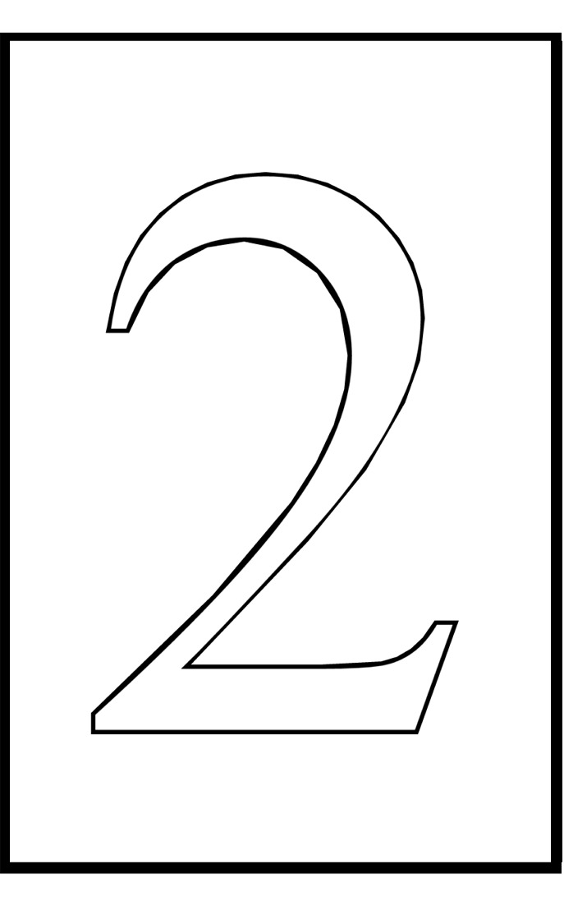
Nominator must be a current member of the CAWA:

Nominator’s
Name:

Telephone:

email:

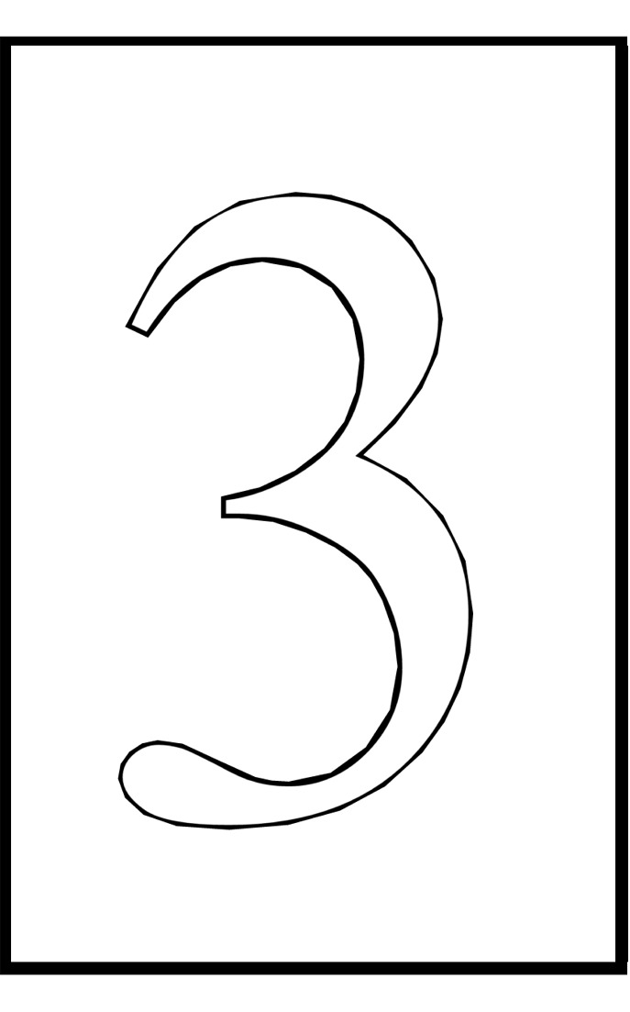
Attach a letter (one page or shorter) to this form and submit to the Board of Directors explaining why this nominee should receive the scholarship. Mail the completed form and letter to the Board of Directors, c/o Dylan Goodson, P.O. Box 3086, Montgomery, Alabama 36109 or present the completed form to a member of the Board.

The deadline for receipt of nominations:
SWS – 15 April All other events – One month prior.

